IBM ASSIGNMENT 1

1. Write a python program to test a given number is prime or not

Program:

num = int(input("Enter a number: "))

flag = False

if num > 1:

for i in range(2, num):

if (num % i) == 0:

flag = True

break

if flag:

print(num, "is not a prime number")

else:

print(num, "is a prime number")

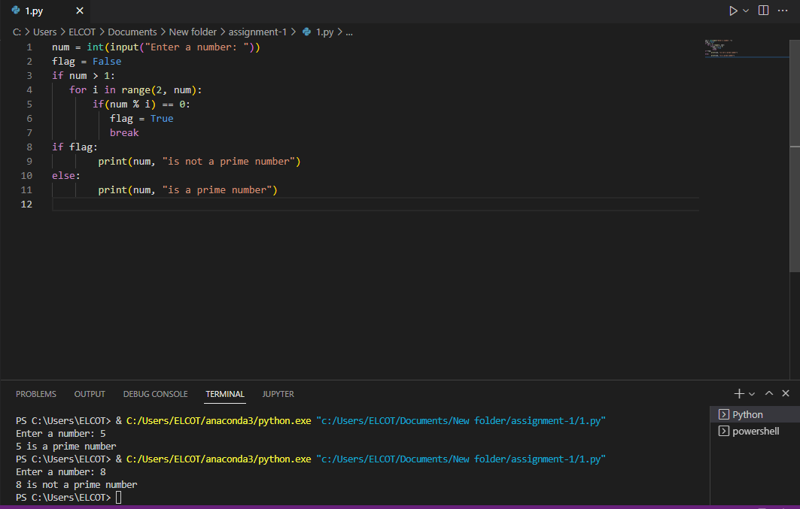

2.Write a program to generate odd numbers from m to n using while loop.

Program:

m= int(input(" Please Enter the M Value : "))

n= int(input(" Please Enter the n Value : "))

for x in range(m,n+1):

if x%2!=0:

print(x)

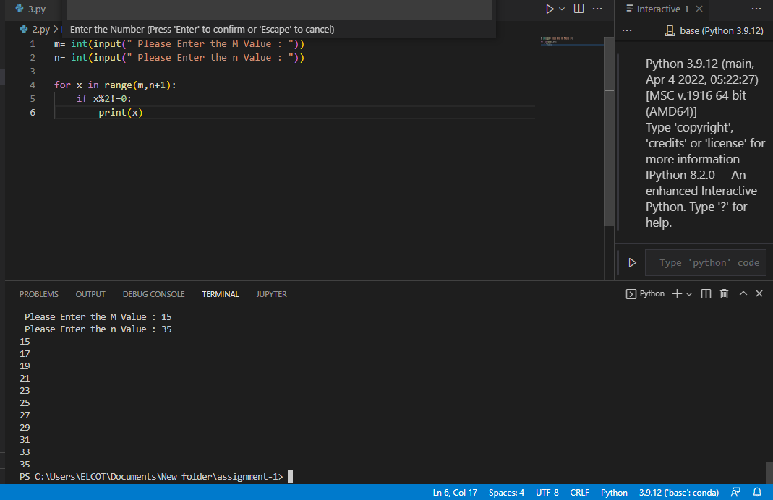

3.Write a python program to display prime number series up to given number

Program:

num = int(input("Enter the Number"))

for number in range(1,num+1):

if number>1:15

for i in range(2,number):

if (number%i)==0:

break

else:

print(number)

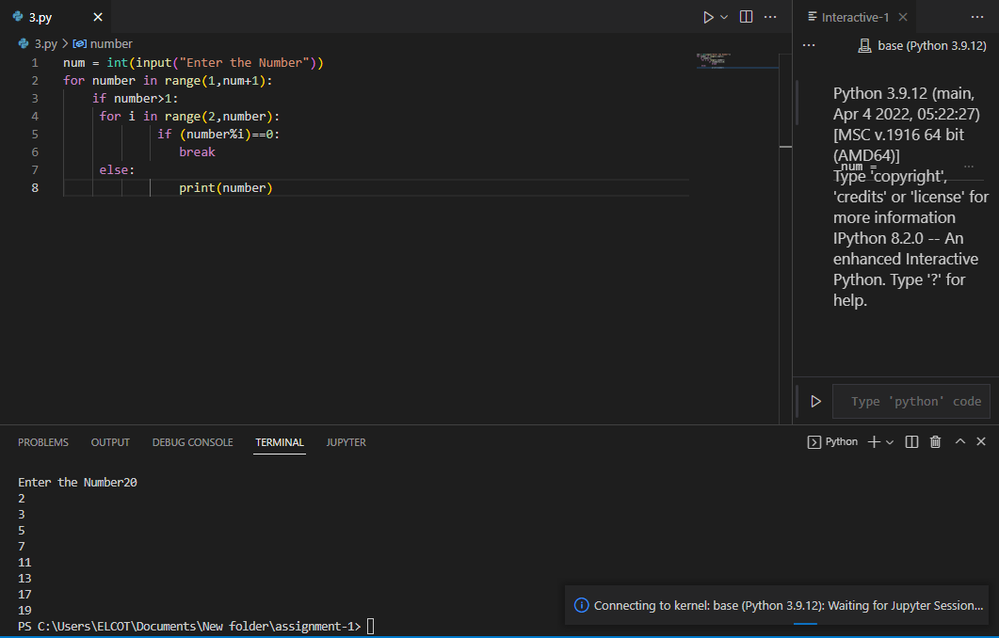

4.Write a python program to generate fibonacci series

Program:

nterms = int(input("Number of terms? "))

n1, n2 = 0, 1

count = 0

if nterms <= 0:

print("Please enter a positive integer")

elif nterms == 1:

print("Fibonacci sequence upto",nterms,":")

print(n1)

else:

print("Fibonacci sequence:")

while count < nterms:

print(n1)

nth = n1 + n2

n1 = n2

n2 = nth

count += 1

